SOLAR AIR-CONDITIONED BED
Syed Asfandyar Ali Kazmi, Talha Ahmad, Hayat Ali, & Muhammad Fahim,
Department of Electrical Engineering, Sarhad University of Science and IT, Peshawar
asfandyaralikazmi@gmail.com
Abstract
Summer is much hot in Pakistan as compare to winter. Therefore adequate source for efficient cooling system is required to make the life comfortable. In conventional air conditioning system most of the cooling is leaked or wasted there, where it is not required. For example cooling around the bed is required instead of the whole room. This paper proposed an efficient cooling system for the above problem. The proposed cooling system is based on the solar air conditioned bed. This cooling system restricts air conditioned environment to reduce cooling losses. The Proposed cooling system operates with renewable energy and main AC source.
Key words: Solar Air-Conditioner, Air-Conditioned Bed, DC Powered Air-Conditioner, DC Compressor
Introduction
Air conditioning is the processing of temperature, humidity, refinement and spreading of air current in the requirement of space needing air conditioning [1]. With increasing electricity tariffs, solar energy becomes attractive once the system has been installed [2]. Solar Air conditioned Bed prototype is initially made for new born babies in which small Air condition system is provided underneath the cart. The Air Condition system is to provide necessary cooling inside the cart only. It is very interesting to know that the amount of cooling by Air Condition system inside the room is equal to the heat throughout by the Air Condition to the outer environment. It means that at the cost of our own room cooling we are heating the outer environment, to minimize this heat balance we should limit our luxurious environment to our real need.
In fact summer in Pakistan is more severe than winter. The death rate of new born babies are high which is caused by hot wave in summer. The babies born in the summer season are badly affected by heat with high humidity, which followed by baby deaths. If we provide air conditioned environment for these babies at least we can control this loss of lives. The most suitable idea is solar air conditioned bed which is partially depend on AC mains electricity and will work in rural areas of Pakistan especially where long load shedding in the summer due to high short fall of electricity.
Summer in Pakistan is more severe than winter and the short fall of electricity is high in rural areas. Everyone but especially babies need air conditioned environment around them but due to short fall of electricity, limit this need. What we are making is the need of the day which is Solar Air Conditioned Bed (for babies) in first phase of the project, which is innovative approach to the problem. In conventional air conditioning systems most of the cooling is wasted in the room where we don’t required which decrease the efficiency of the system. We confined the air conditioned environment around the bed which we really need and control the heat leakage to improve the efficiency and decrease running cost of the air conditioning system.

Model Description
Either for a house or an automobile, the air conditioning system consists of five main components which are compressor, expansion, evaporator, refrigerant and condenser [3].
A compressor is the heart of the air conditioning system in which refrigerant is compress to increase the temperature and pressure of supplied gaseous refrigerant. Expansion valve is used to expend refrigerant immediately to increase the temperature and pressure. The working of the evaporator is opposite of the condenser. In evaporator refrigerant liquid is converted to gas, absorbing heat from air in the room. Refrigerant is a cooling agent which absorb heat from surrounding and will complete the cycle inside the circuit of the air conditioning system. 1,1,1,2-tetrafluoroethane, R-134a, Forane 134a, Genetron 134a, Florasol 134a, Suva 134a orHFC-134a, also known as norflurane (INN), is a halo alkane refrigerant with thermodynamic properties similar to R-12.A condenser are simply small width pipes which are used to decrease the temperature of refrigerant by blowing air through it.
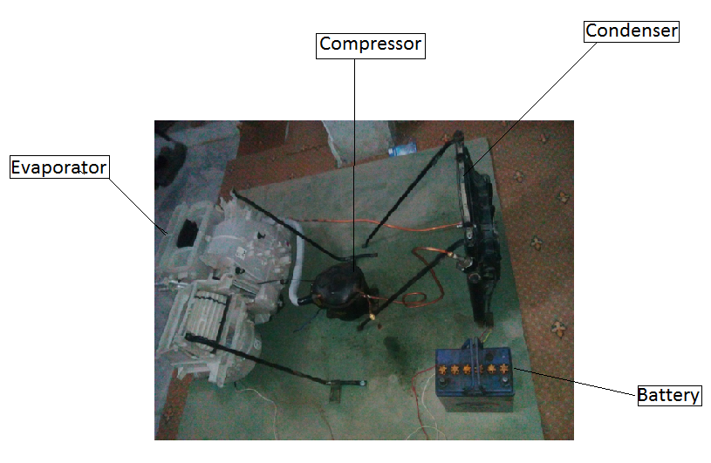Figure1. Prototype of solar air condition system.
This prototype consists of a Compressor, Evaporator, Condenser and Battery. The copper pipe is connecting all the components with each other. The discharging side of the Compressor is connected with the inlet of the condenser. The outlet of the condenser is connected with the capillary tube and then capillary tube is connected with the Evaporator with the help of Expansion Valve. Then the outlet of the Evaporator is connected with the inlet of the compressor this completes the refrigeration cycle.
The calculation of the battery time is.
Charging current should be 10% of the Ah rating of battery.
Charging Time of battery = Battery Ah / Charging Current, £ = Ah / A.where £= Charging Time of Battery So 10% of 200Ah is 20A current Then£ =200/20. The result will be £=10 Hours.
Discharging time of battery can be calculated as Discharging Time= battery capacity* Volts/Total power. In mathematical form we can write as β=Ah * V/W. where Discharging Time = β we use 200Ah Battery, 12 volt &500 watt total load Then, β=200*12/500. The result will be β=4.8 Hour
Power Rating for Solar Panel, The idea is 200Ah at 12 V (DC) we need to apply the 10hr charging method, so 10% of 200Ah gives 20A.In calculation we can write as 200Ah/10h = 20A. So power of needed solar panel is computed as follows, 12V⋅20A=240W. So the power of panel is 240 W.
Result
On the observation of upper calculation the result can be obtained as
Table 1. Starting Results of the proposed design.
Compounds | Voltage (v) | Current (A) | Power (P) | Efficiency (%)
Compressor | 12 | 22.5 | 270 | 93
Evaporator | 12 | 7.5 | 90 | 95
Condenser | 12 | 7.5 | 90 | 90
Fans | 12 | 4.1666 | 50 | 100
Table 2. Running Results of the proposed design.
Compounds | Voltage (v) | Current (A) | Power (P) | Efficiency (%)
Compressor | 12 | 4 | 48 | 98
Evaporator | 12 | 2.5 | 30 | 98
Condenser | 12 | 3.5 | 42 | 98
Fans | 12 | 4.1666 | 50 | 100
Conclusion and Future Work
This paper concludes that the air condition system design needs to consider PV system in order to achieve the space cooling. For the air conditioning, cooling size must be determined first so that it will give a rough idea about the design and construct the air condition system with enough electrical energy as well as solar energy supplied to it. With considering of these several factors, all these factors will help to improve the strength and efficiency of the system for the solutions to the world’s energy needs.
In future we will use DC Compressor with the help of which we can improve more efficiency of our System. After than we will install sensor for Calculating different parameters of the system for better data logging and use deep-cycle batteries in our project.

References
[1] M, Ochi.; and K, Ohsumi,. “Fundamental of Refrigeration and Air Conditioning”: Ochi Engineering Consultant Office; 1989.
[2] J,Bvumbe, and F. L.Inambao,. “Solar Powered Absorption Cooling System for Southern Africa”. University of Kwazulu-Natal, Durban, South Africa; 2011.
[3] T. Tsoutsos, E. Aloumpi, Z. Gkouskos, and M. Karagiorgas. “Design of a Solar Absorption Cooling System in a Greek”Hospital. Energy and Buildings; 2009.
[4] I. Daut, M. Adzrie, M. Irwanto, P. Ibrahim, M. Fitra, “Solar Powered Air Conditioning System”aCentre of Excellence for Renewable Energy, School of Electrical System Engineering, Universiti Malaysia PerlisTaman Pengkalan Indah, JalanPengkalanAssam, 01000 Kangar, Perlis, Malaysia;TerraGreen13 International Conference, Energy Procedia 36 ( 2013 )PP444 – 453.
[5] R.McDowall, “Fundamentals of HVAC System American Society of Heating, Refrigerating and Air-Conditioning Engineers”, Inc and Elsevier Inc., 1st edition; 2007.

